Subordinate Court Secretaries

Please send the names of your deceased members to the Grand Secretary no later than August 20, 2024

Your 2024 dues cards must be presented to the Registration Committee. Your credential card, properly signed, must be presented to the Credentials Committee prior to Saturday, September 14, 2024 by 8:30am.

Turn in your jewel to the Chairman of Trustees no later than 12 noon Saturday, September 14, 2024

Royal Matrons, please bring your crowns, Royal Patrons, please bring your swords.

New members, or anyone attending Grand Court for the first time, please come and enjoy yourselves and be a part of the activities. Honored Ladies may wear formal attire or dresses, no slacks please. Sir Knights should wear business suits or tuxedos. Please feel free to ask questions.

Grand Court Session Chairman
S.K. Jim LeFlore
6530 Richardson Hwy
Salcha, Alaska 99714-9766
907-388-7051

“Spirit of Alaska “Fly-in for the Cure”
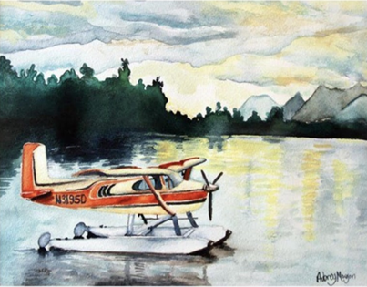

GRAND COURT OF ALASKA
ORDER OF THE AMARANTH
Extends Fraternal Greetings
And Cordially Invites
You to join us at…

51st Annual Session

“Spirit of Alaska, FLY-IN for the Cure”

Thursday, Friday and Saturday
September 11-14, 2024

Anchorage, Alaska

Grand Royal Matron
HL Carol Addison Lippert

Grand Royal Patron
SK James “Jim” LeFlore

H.L. Brenda Crothers
Grand Secretary

September 11-14, 2024

Please make reservations for your
Hotel accommodations by
August 20, 2024

Hotel link below

https://www.millenniumhotels.com/en/bookings/?
hotelcode=13543&checkin=2024-09-11&
groupcode=2408GRANDC

The Lakefront Anchorage Hotel
4800 Spenard Rd. Anchorage, Ak 99517
907-243-2300

Hotel provides a shuttle service from the airport.

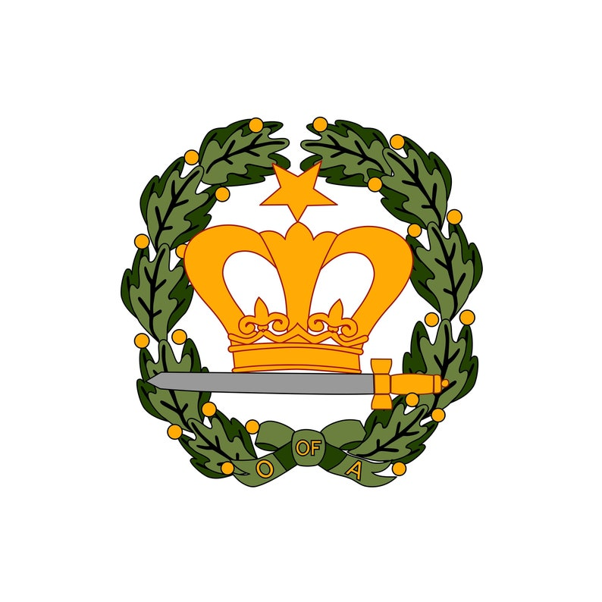

Schedule of Events

Wednesday September 11, 2024
Alaska Aviation Museum
Social Gathering
5:15pm Bus pick up at Hotel

Thursday September 12, 2024
Alaska Wildlife Conservation Center
8:45am Bus pick up at Hotel.

REHEARSAL SCHEDULE

All rehearsals will be under the direction of Grand Lecturer. Please be on time and ONLY those involved are to be in the Court Room. All Practices are to be held in the Grand Court room.

Practices:

2:00pm Grand Marshals, Grand Conductresses and Grand Standard Bearer
2:30pm Grand Floor Officers, Informal and Formal Opening
3:00pm Escort
3:30pm Memorial Ceremony, GRM, GRP, Ladies of the Square, GC, GAC, GSTB, GME, GMW, GPREL, and Eulogist
4:00pm Necrology – RM’s, RP’s

REGISTRATION AND CREDENTIALS DESK OPEN
Thursday, September 12, 2024 4:00-6:00pm
Friday, September 13, 2024 7:45 -8:30am
Saturday, September 14, 2024, 7:45-8:30am

Program

Thursday September 12, 2024
6:30 pm Musical Prelude
Escort of Distinguished Guests
7:00 pm Informal Opening,
Masonic Family Night

Reception honoring the Supreme Royal Matron and Supreme Royal Patron
EVERYONE IS INVITED

Friday September13, 2024
8:45am Musical Prelude
9:00am Call to Order,
Ritualistic Opening, Escort,
and Reports
12: 00 pm Luncheon
2:00 pm Call to Order
Continue Reports
NECROLOGY
MEMORIAL Ceremony

BANQUET “Northern Exposure”
Honoring Grand Royal Matron’s &
Grand Royal Patron’s. Alaska theme
costumes are encouraged or formal attire.

5:30pm No-host Social Hour
6:30pm Dinner

Saturday September 14, 2024
8:45am Musical Prelude
9:00am Call to Order
10:00 am Election of Officers
12:30 pm Luncheon
2:00 pm Call to Order (if necessary)
7:00 pm Installation of New Grand Officers

Reception to Follow

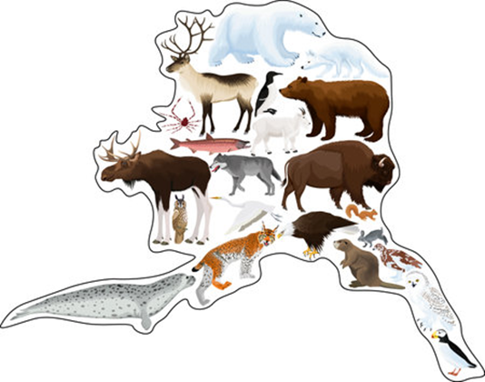

GENERAL INSTRUCTIONS

Grand Officers: Please memorize the charges for Grand Court, pages 235 -249, inclusive.
Memorial Ceremony on pages 255- 259, of the 2015 Revised Ritual.

Grand Officers and Committee Chairman:
Be prepared to give your report when called upon. All reports should be typewritten on
8 ½ x 11 paper and doubles spaced. One copy is to be filed with the Addresses and Distribution Committee Chair during Thursday’s registration and one copy given to the Grand Royal Matron following report. Delinquent reports will not be printed in the proceedings.

If unable to attend the Grand Court Session,
Please notify the Grand Royal Matron no later
than August 20, 2024

